# Source Control History

|  |  |
| --- | --- |
|  |  |
| Date | **Evidence** |
| 05/11/2020 (Thursday) | Ref 1 |
| 06/11/2020 (Friday) | Ref 2 |
| 09/11/2020 (Monday) | Ref 3 |
| 10/11/2020 (Tuesday) | Ref 4 |
| 11/11/2020 (Wednesday) | Ref 5 |

Ref 1

1. 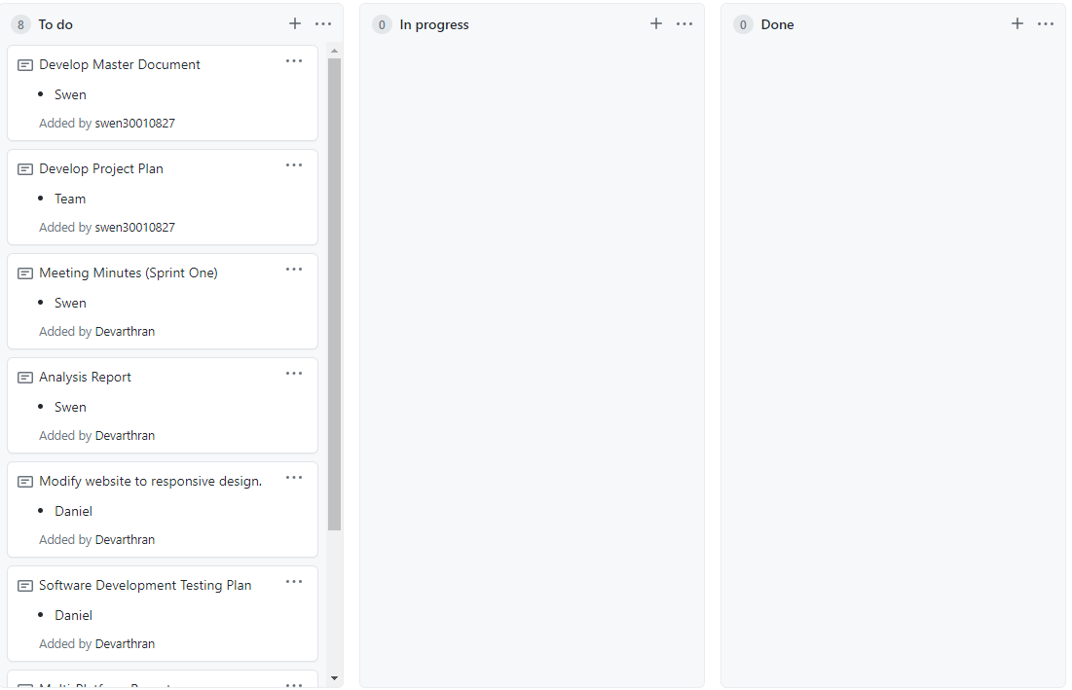
2. 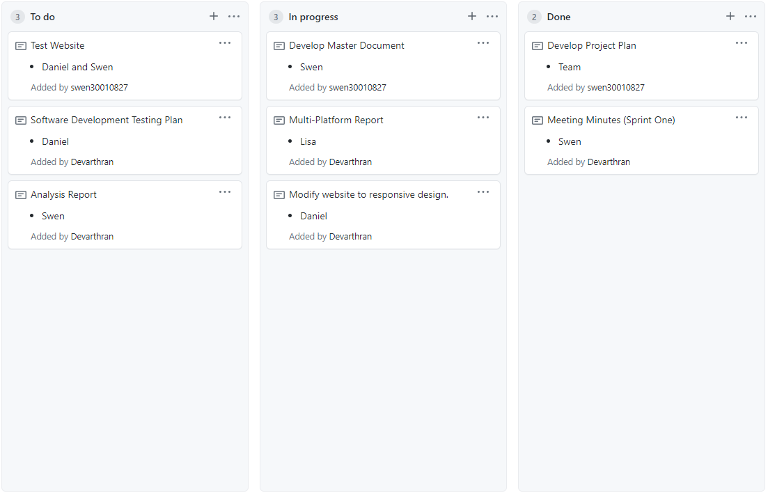

Ref 2

1. 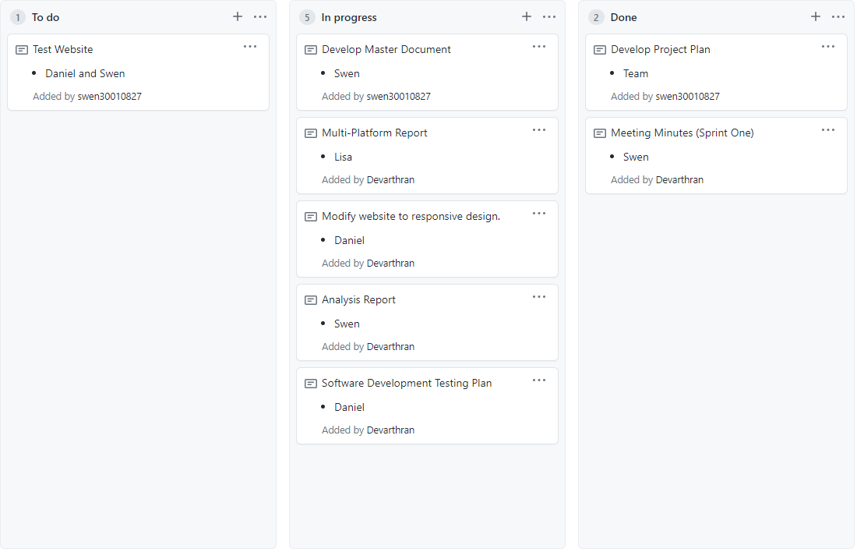

Ref 3

1. 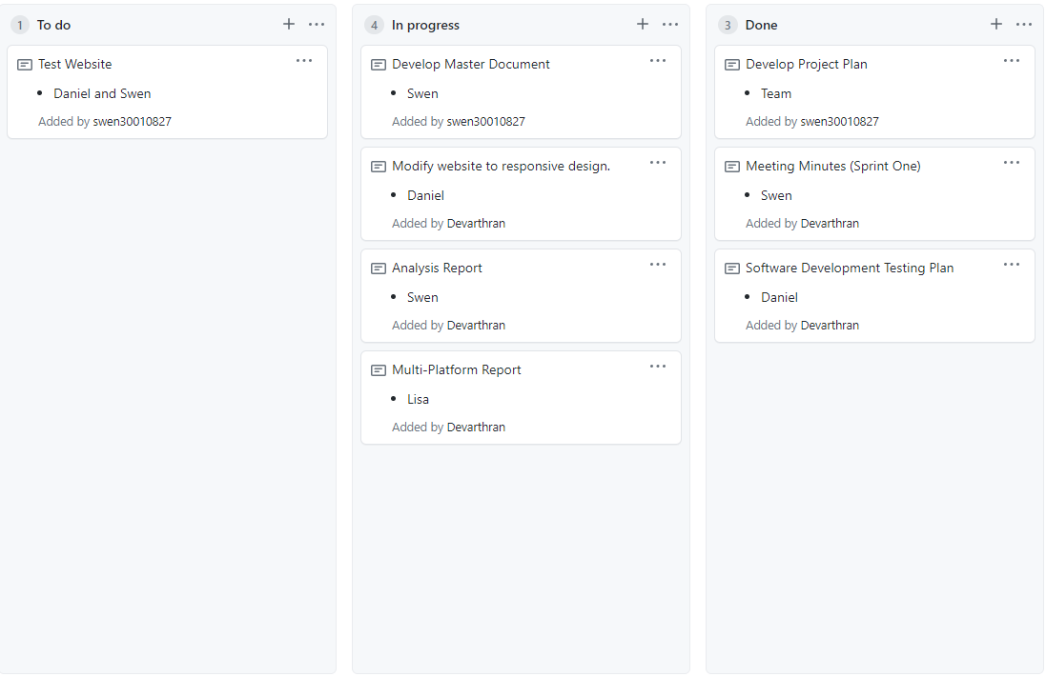

Ref 4

1. 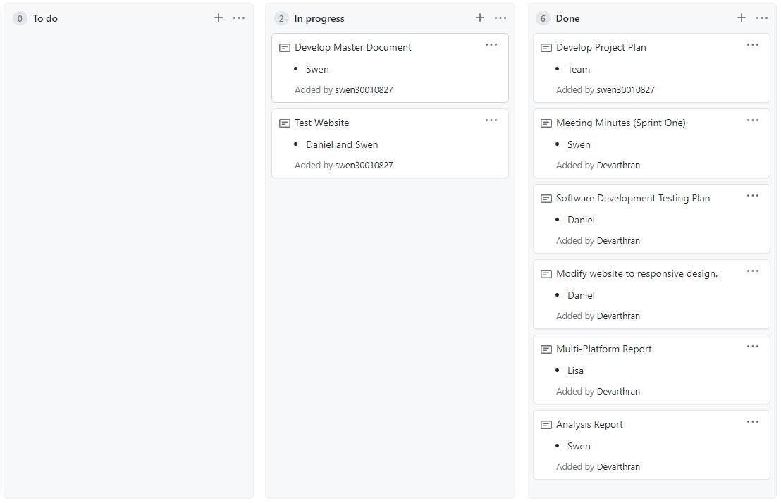

Ref 5

1. 